

Sky Smart Technology (Pvt) Ltd.

**Sustainability Web Application**

**ER Diagrams**

**For**

**Health and Safety Module**

**Version 1.0**

Date Created: 09/04/2025

Created by: Chandima Samarakoon

Table of Contents

Hazard and Risk 3

Accident Management 3

Incident Management 4

Document 4

Occupational Health 4

# Hazard and Risk

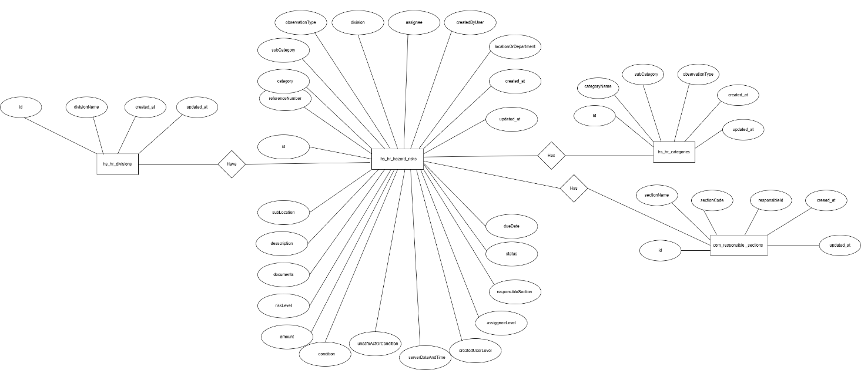

# 

# Accident Management

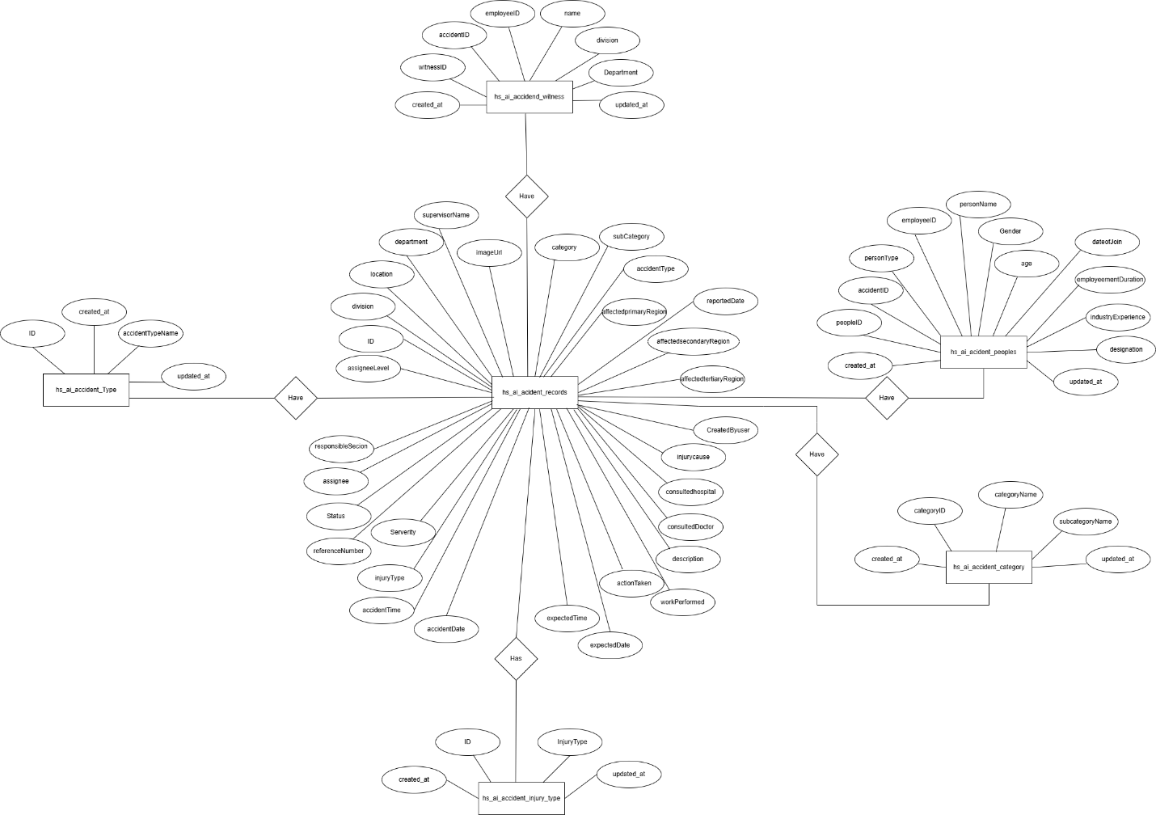

# Incident Management

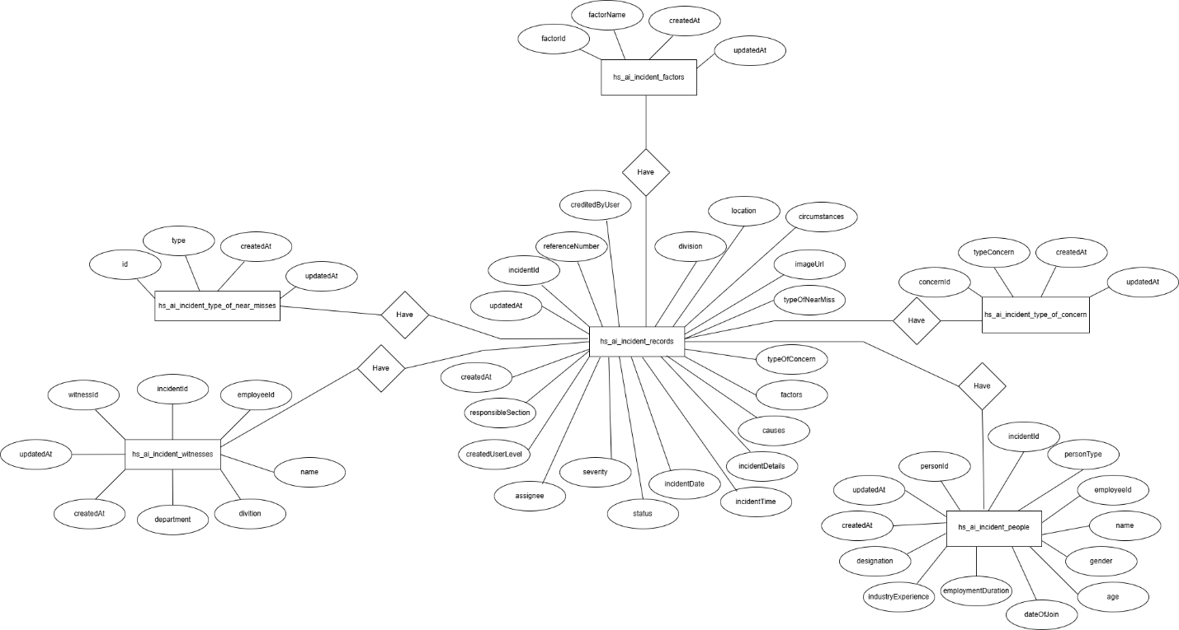

# Document

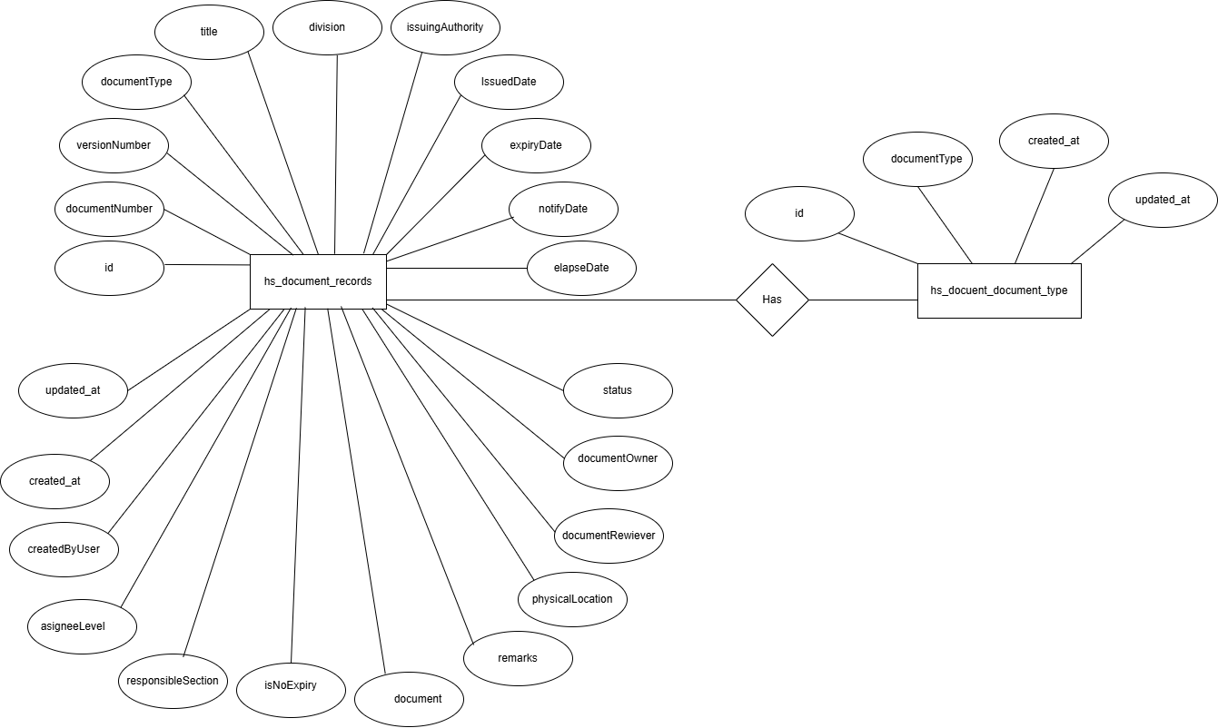

# 

# Occupational Health

